Annual Meeting of the Figure Skating Club of Cincinnati
June 21, 2021 and Oct. 13th, 2021

For the 2020-2021 season the actual face to face annual meeting was held on Oct. 13th, 2021. We were not able to hold a meeting in June because of conflicts. However, an online vote for the board and finance committee plus a constitution change was conducted via Survey Monkey.

June 21st Vote:

Members who responded to survey – Quorum requirements met:
Laura Moreland, Melissa Townsend, Betsy Neyer, Stacy Hodgett, Lisa Butler, Warren King, Flannery Higgins, Dottie Janson, Kelly McCormick, Mimzi Staten, Cathy Brinkman, Ginny Sefton, Kat Bohman, Don Bowman, Stacey Udstuen

Q1:
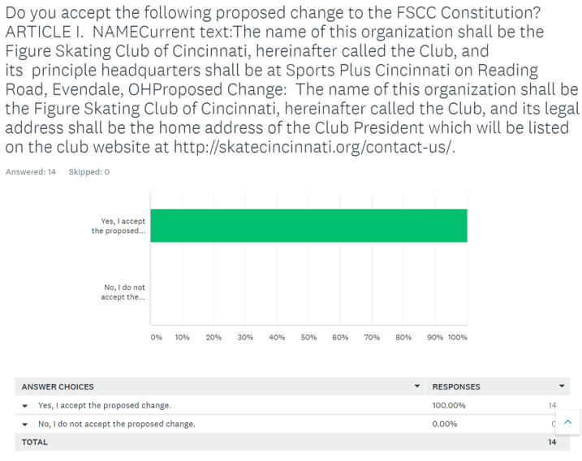

Board Member and Finance Committee Elections:
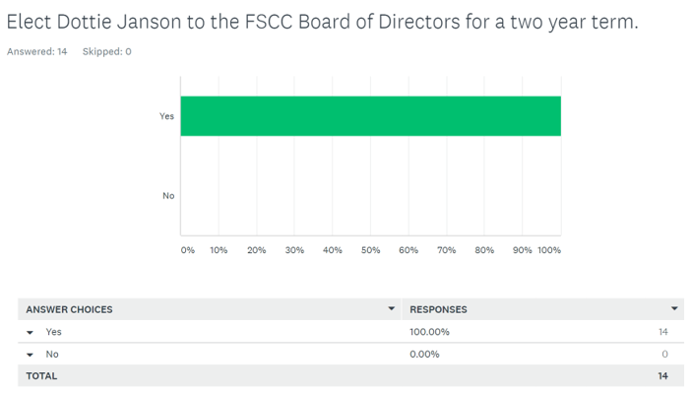

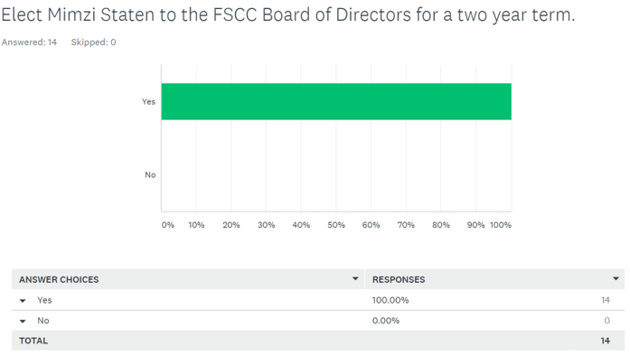

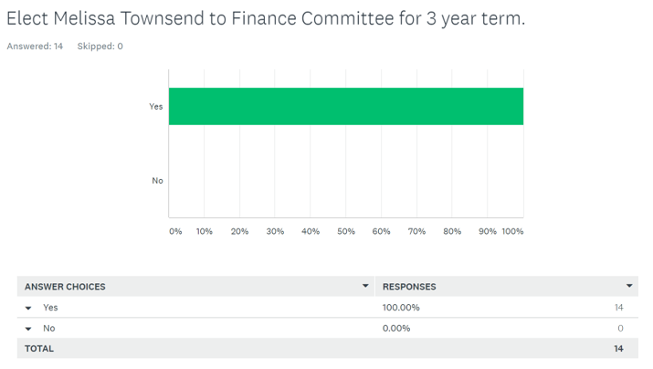

Oct. 13th FSCC Skate and Celebrate Event

The meeting was called to order by President Dottie Janson.

Welcome and introductions were done. Four club members attended. There were not enough members in attendance to reach quorum. Thus last year’s annual meeting minutes were not reviewed and approved.

Agenda:
- Review of last year’s minutes | 4. Constitution and Bylaws
- President’s Report | 5. Elections
- Awards and Test Certificates

President’s Report
- Current Membership: 52 members (2020/21 season: 65 members)
  - 15 families (2 members each + 4 additional family members)
  - 9 adult, 2 professionals, 2 collegiate
  - 5 Non-FSCC IHWC Synchro
  - 29 voting members (30% needed for quorum)
- Last Season:
  - Two Test Sessions offered
  - Skate Cincinnati planned for April, but was canceled because of Covid
  - Offered three on-line seminars:
    - Stretching
    - Psychology of Testing and Competing
    - Warren King – How Skating Tests are Evaluated
- We are changing our Home Rink to Indian Hill Winter Club
  - This offers us the ability for more synergy with IHWC and opportunities for our FSCC members
  - This does not allow FSCC members access to IHWC ice sessions unless you also join IHWC
- Skate Cincinnati - Planning to host again in April, 2022
- Test Sessions - Planning to host at least 2 test sessions this season
- Seminars - Planning to hold a few more on-line seminars. Will invite coaches of FSCC members as well.
    - Beading Dresses
    - Another Psychology of Testing and Competing
    - Another Judging session – Maybe How do Judges Evaluate Choreography
    - Any suggestions for topics or speakers are welcome.

Volunteers:
- FSCC is a volunteer-run, non-profit organization that depends on our membership to help the club support skating-related events.
- We are requesting each of you to agree that an acceptable number of volunteer hours is a minimum of 4 (four) hours per member skater per year.
- Please sign up for one of our critical Volunteer needs listed below. There is training available for each role listed:
- __Board Member: 2-3 hours per month | - __ Competition – Day of: 4 hours per shift (for example, playing music, ice monitor)
- __Website Content: 2 hours per quarter | - __ Test Session – Day of: 4 hours per shift (for example, playing music, ice monitor)
- __Competition Registration co-chair: 4 hours/month in Jan, March & April - setup registration system & tally entries. | - __ Awards coordinator: 1-2 hours in May/June to send survey and tally votes
- __Competition Volunteer coordinator: 4 hours in April | - __Social Media: 1 hour/quarter
- __Hospitality coordinator: 1-2 hours of planning per test session/competition | - Newsletter: 2 hours/bi-monthly
- __Competition Volunteer coordinator: 4 hours in April | - Seminars Coordinator: 1-2 hours/quarter

Test Certificates:
- Mimzi handed out test certificates for the season

Club Awards:
- Dottie presented the club awards for the season:
- Brintnall Most Improved – Teigan Ellis
- Erdman Artistic Award – Jessie Kong
- Shipley Dance Award – Ashley Udstuen
- Betty Lee Duvall Sportsmanship Award – Maggie Schoeny
- Giffin Club Award – Warren King

Graduating Seniors:
- Dottie congratulated the graduating seniors from last May/June:
- Katia Cristo
- Rose Joffee
- Lila Joffee
- Jessie Kong
  - Jessie also was a winner of the USFSA Graduating Seniors Silver Award

Meeting was adjourned at 8pm.

