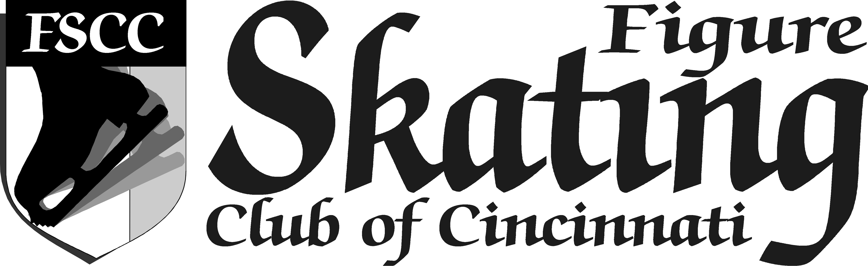

**C:\Users\Laura\AppData\Local\Microsoft\Windows\Temporary Internet Files\Content.IE5\MSFS2IKF\MC900022528[1].wmfC:\Users\Laura\AppData\Local\Microsoft\Windows\Temporary Internet Files\Content.IE5\MSFS2IKF\MC900022528[1].wmfCONGRATULATIONS**

**SKATERS!!**

**FSCC congratulates our members on their US Figure Skating test achievements:**

|  |  |
| --- | --- |
| Paige Ellingson | **~ November 1, 2015 ~**  Juvenile Moves In the Field |
| Sammy Murray | Intermediate Moves In The Field |
| Margaret Schoeny | Pre Juvenile Moves In The Field |
| Kurt Schwab | Masters Fourteenstep |
| Kurt Schwab | Masters Foxtrot |
| Patricia Schwab | Masters Foxtrot |
| Patricia Schwab | Masters European Waltz |
| Ryan Sohmer | Preliminary Moves In The Field |
| Jordan Sovik | Juvenile Moves In the Field |
| Sophia Zou | Juvenile Moves In the Field |
| Sophia Zou | Juvenile Free Skating |
| Rebekeh Jonas | **~ August 22, 2015 ~**  Cha Cha |
| Rebekeh Jonas | Fiesta Tango |
| Katherine Bowman | **~ July 31, 2015 ~**  Juvenile Moves In the Field |
| Katherine Bowman | Juvenile Free Skating |
| Olivia Yackman | **~ July 30, 2015 ~**  Juvenile Free Dance |
| Olivia Yackman | Hickory Hoedown |
| Olivia Yackman | Willow Waltz |
| Mikal Stoughton | **~ July 24, 2015 ~**  Swing Dance |
| Mikal Stoughton | Cha Cha |
| Katherine Bowman | **~ June 18, 2015 ~**  Pre Juvenile Free Skating |

If you are a non-home-club FSCC member who would like to see your test results listed here, please send a message to [testing@skatecincinnati.org](mailto:testing@skatecincinnati.org) including details of your recent test accomplishments!